Meeting Record
13-09-2023
ME 3356 + Discord

Attendance

Executive | Y/N | Members
Xavier Haziza, President | Y | Cameron barlow
Declan McCloskey, VP Internal | Y | Robert Zoltan
Monica Paul, VP External | Y | Kyle Weir
Naomi Yakubovich, VP Finance | Y | Dana
Cynthia Cairns, VP Services | Y | Ellilan (non member)
Maxim Kari, Events Director | Y | Logan Rabb
Grace Smith, Events Director | Y | Eric justC
Liam D-P, Inventory Director | Y | Ava
Piper Stuempel, Merchandise Director | Y | Olivier (non member)
Jaime tenBrinke, Office Director | Y | Bramble (photography)
Liz Antifave, Publications Director | Y | Khaled
Sam Raab, Technical Director | Y
Jules Breau, 4th Year Rep | N
Jaden Desveaux, 3rd Year Rep | Y
Lexy Buchanan, 2nd Year Rep | N
1st Year Rep
1st Year Rep
1st Year Rep

Meeting Agenda
Schedule
18:30-19:00 | Action Items
19:00-19:30 | Executive Updates  Speaking Order:  - President  - VPI  - VPX  - VPF  - VPS  - Events  - Inventor Director  - Merchandise Director  - Office Director  - Publications Director  - Technical Director  - 4th Year Representative  - 3rd Year Representative  - 2nd Year Representative  - 1st Year Representatives
19:30-19:45 | Discussion Period

Action Items
Subject: Handbook update |  | Amend Article 7.2 of the CMAS Handbook to state “The current membership fee is $10 per individual, in Canadian dollars.”  CMAS Rules & Regulations Handbook 2023
Brought forward by: VPI
Result: Passes unanimously
Subject: Job for Co-Junior Ladders |  | Put up the blinds please? 👉👈
Brought forward by: Office
Result: Laddering

Minutes
Legend: New item In progress Late General

Executive Updates | Notes
President | 3 minutes
- Attended a department meeting on monday
  - Karen taylor is now the academic advisor for MAE!!
  - New services are live for 3d printing, machining, etc. Liz is going to make a poster for it and I will make an announcement on the discord. This should hopefully reduce our 3d print load!!
  - Potential new 4th year machine learning course.
- Meeting with monica and CASI about affiliate stuff soon ™
- Meeting with IEEE to hash out CO2 car comp soon ™
- Coordinating with machine shop guys to see if we can organize some machine shop training
- Meeting with dana next week to get started on the stuff regarding their portfolio
- Cyr contacted me about CASI conference volunteer opportunity
Vice President Internal | 1 minute
- First Year Representative applications
  - Open now
  - Form closes 19 Sep 2023
- CSA Engineer position application - closes Friday the 15th!
Vice President External | 7 minutes
- Engine Icing CASI Talk
  - Thurs. Sept 21, 6:30pm
  - ME 3275
  - Pizza? Or snacks and refreshments? (CASI will split cost)
  - Jim MacLeod fromm NRC Aerospace Research Center
  - Liz will be posting for this tonight - Year reps pls plug to your classes and frosh teams <3
- CSA DFL Tour
  - Fri. Oct 27, 8:30-10:30am
  - Working on a signup form
  - Limit to 20 people
    - Depending on popularity could look to do a second tour later?
- Test Bed 80 Talk
  - Tuesday Nov 2
  - Location and time TBD
  - Speakers from MDS - talking about design, development, and construction of Test Bed 80
- Met with event about paper airplane
- Setting up a meeting with Xav and CASI for student branch discussion
- CMAS student representation doc
  - Pls give me feedback - comment on the document <3
- Helped Xav with FED Fair
  - Was awesome, talked to a lot of interested people (even someone in neuroscience - they like engines)
- Space-bound
  - Its actually in the middle of midterms - not sure if its worth it
  - If we want it - I can not bring/supervise the peoples
- Meeting with Liz soon to discuss pubs committee
- MY AGENDA:
  - Look into CSME, ASME, any other industry societies people are interested in? (let me know)
  - Meet with Jake about co-op conference and poster fair

Vice President Finance | 7 minutes
- Financial Report
- https://docs.google.com/spreadsheets/d/1BdQrylMqUNO37__VVqrlKrgtSUgaTnNP9O8AqAK7ReY/edit#gid=0
- One week to submit what you want funded from CUSA
  - - Digital or In-Person Event Logistics
  - - Guest Speaker Compensation
  - -Events/Activities that directly tie to a club's mandate and goals
  - -Bank Fees
  - -Infrastructure or equipment

Vice President Services | 4 minutes
- Calliper update
  - Would be 2 shipments of 25 units.
  - Order more expensive by about 50$
  - Deadline September 30
- Services committee meeting
  - No times worked where all services exec worked so we had it before the meeting
  - Discussed goals and feasibility of projects and timelines
Events Directors | 4 minutes
- Paper airplane  - Paid for the field house for paper airplanes  - CASI partnership  - They’ll do a talk and RC plane demo :)  - 3 categories  - Farthest (8.5x11 paper only)  - Accuracy (8.5x11 paper only)  - Coolest design (any materials, we will not supply)  - Prizes  - Lego 👀  - Merch maybe  - Looking for good places to run Folksy 1  - UC Foyer area seems good so people can break off and talk to their reps  - We can also book the lobby area in Tory  - Not too keen on lecture halls because its awkward to breakoff  - Bell theatre lame  - Leos was too small last year :(  - Making updated forms  - Events Feedback  - Gonna consult with Dana for the section on accessibility  - Event Ideas | -EDC atrium for folksy 1 (get design teams to open bays for us to use?)
Inventory Director | 2 minutes
- Beginning stock count of all non purchasable consumables (coffee, milk, hot chocky, etc)
  - Completed list will be sent to services (and anyone else who wants it) when completed
  - Updated bi-weekly* (hopefully)
- Library to be up and running soon.
  - Need to familiarise with the form that exists
  - Most likely 2 books per person*
  - 2 week loan period.
  - Channel in discord showing current availability of books for members?
Merchandise Director | x minutes
- I sent an email to accent logos about the shirts - no response yet. I chatted with Monica (old services) and apparently you need to call to actually get a response to your email. I will give them a call
  - If accent logos falls though I have another potential supplier but I know nothing about them (idk how reliable they are) https://www.korosi.com/p/RNIYE-OYZDH/custom-dye-sublimation-hawaiian-shirt-stretch-poly
  - My goal is to sell the shirts for under 30$ which means that we can only buy them for 20$ each
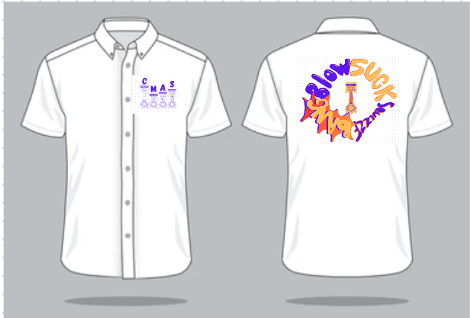
- I will be taking over the patch designs. If you want one done talk to me (Liz is busy enough without taks outside of their portfolio)

Office Director | 4 minutes
- Yearly Office Cleaning  - Bleach was not strong enough  - Chisel!!  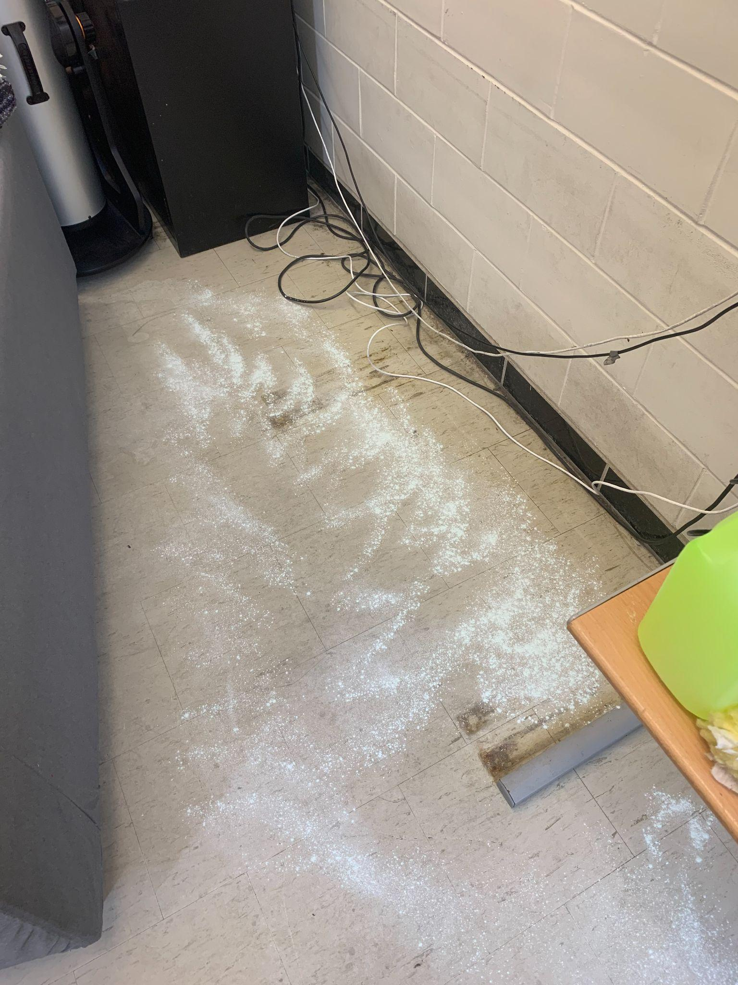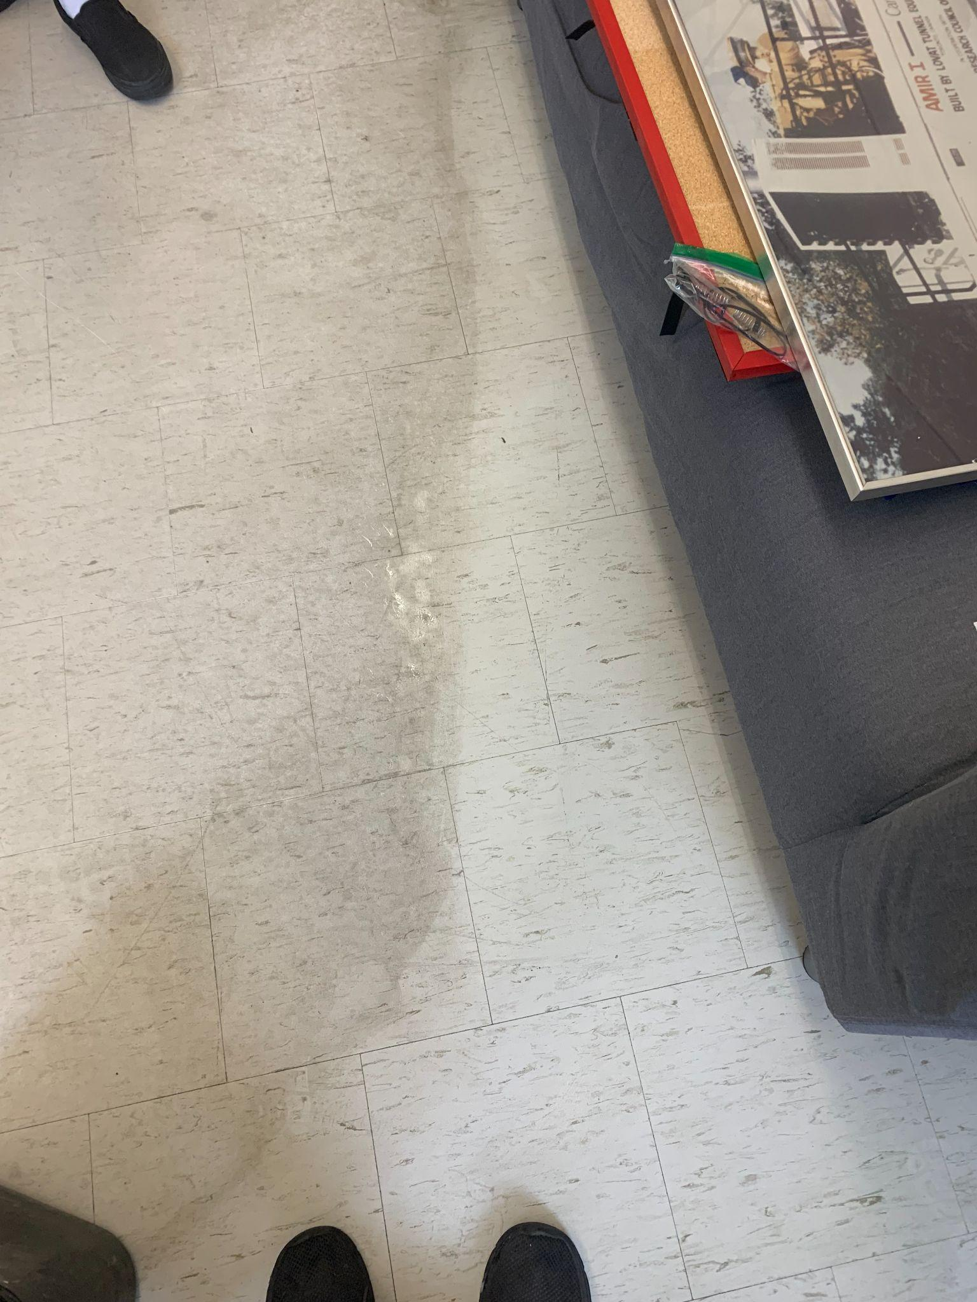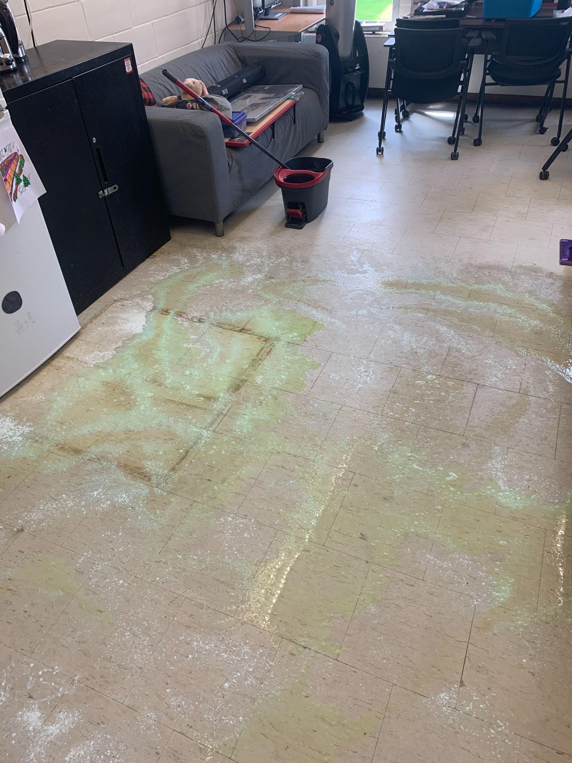  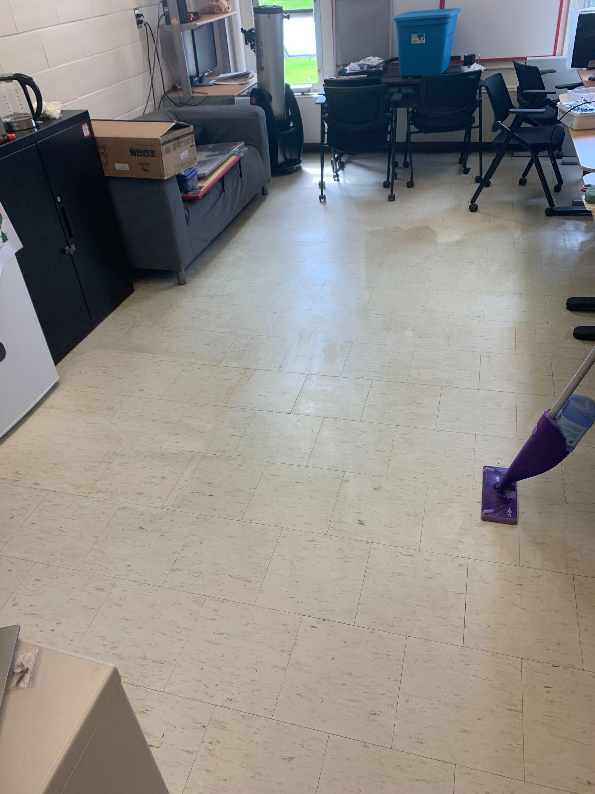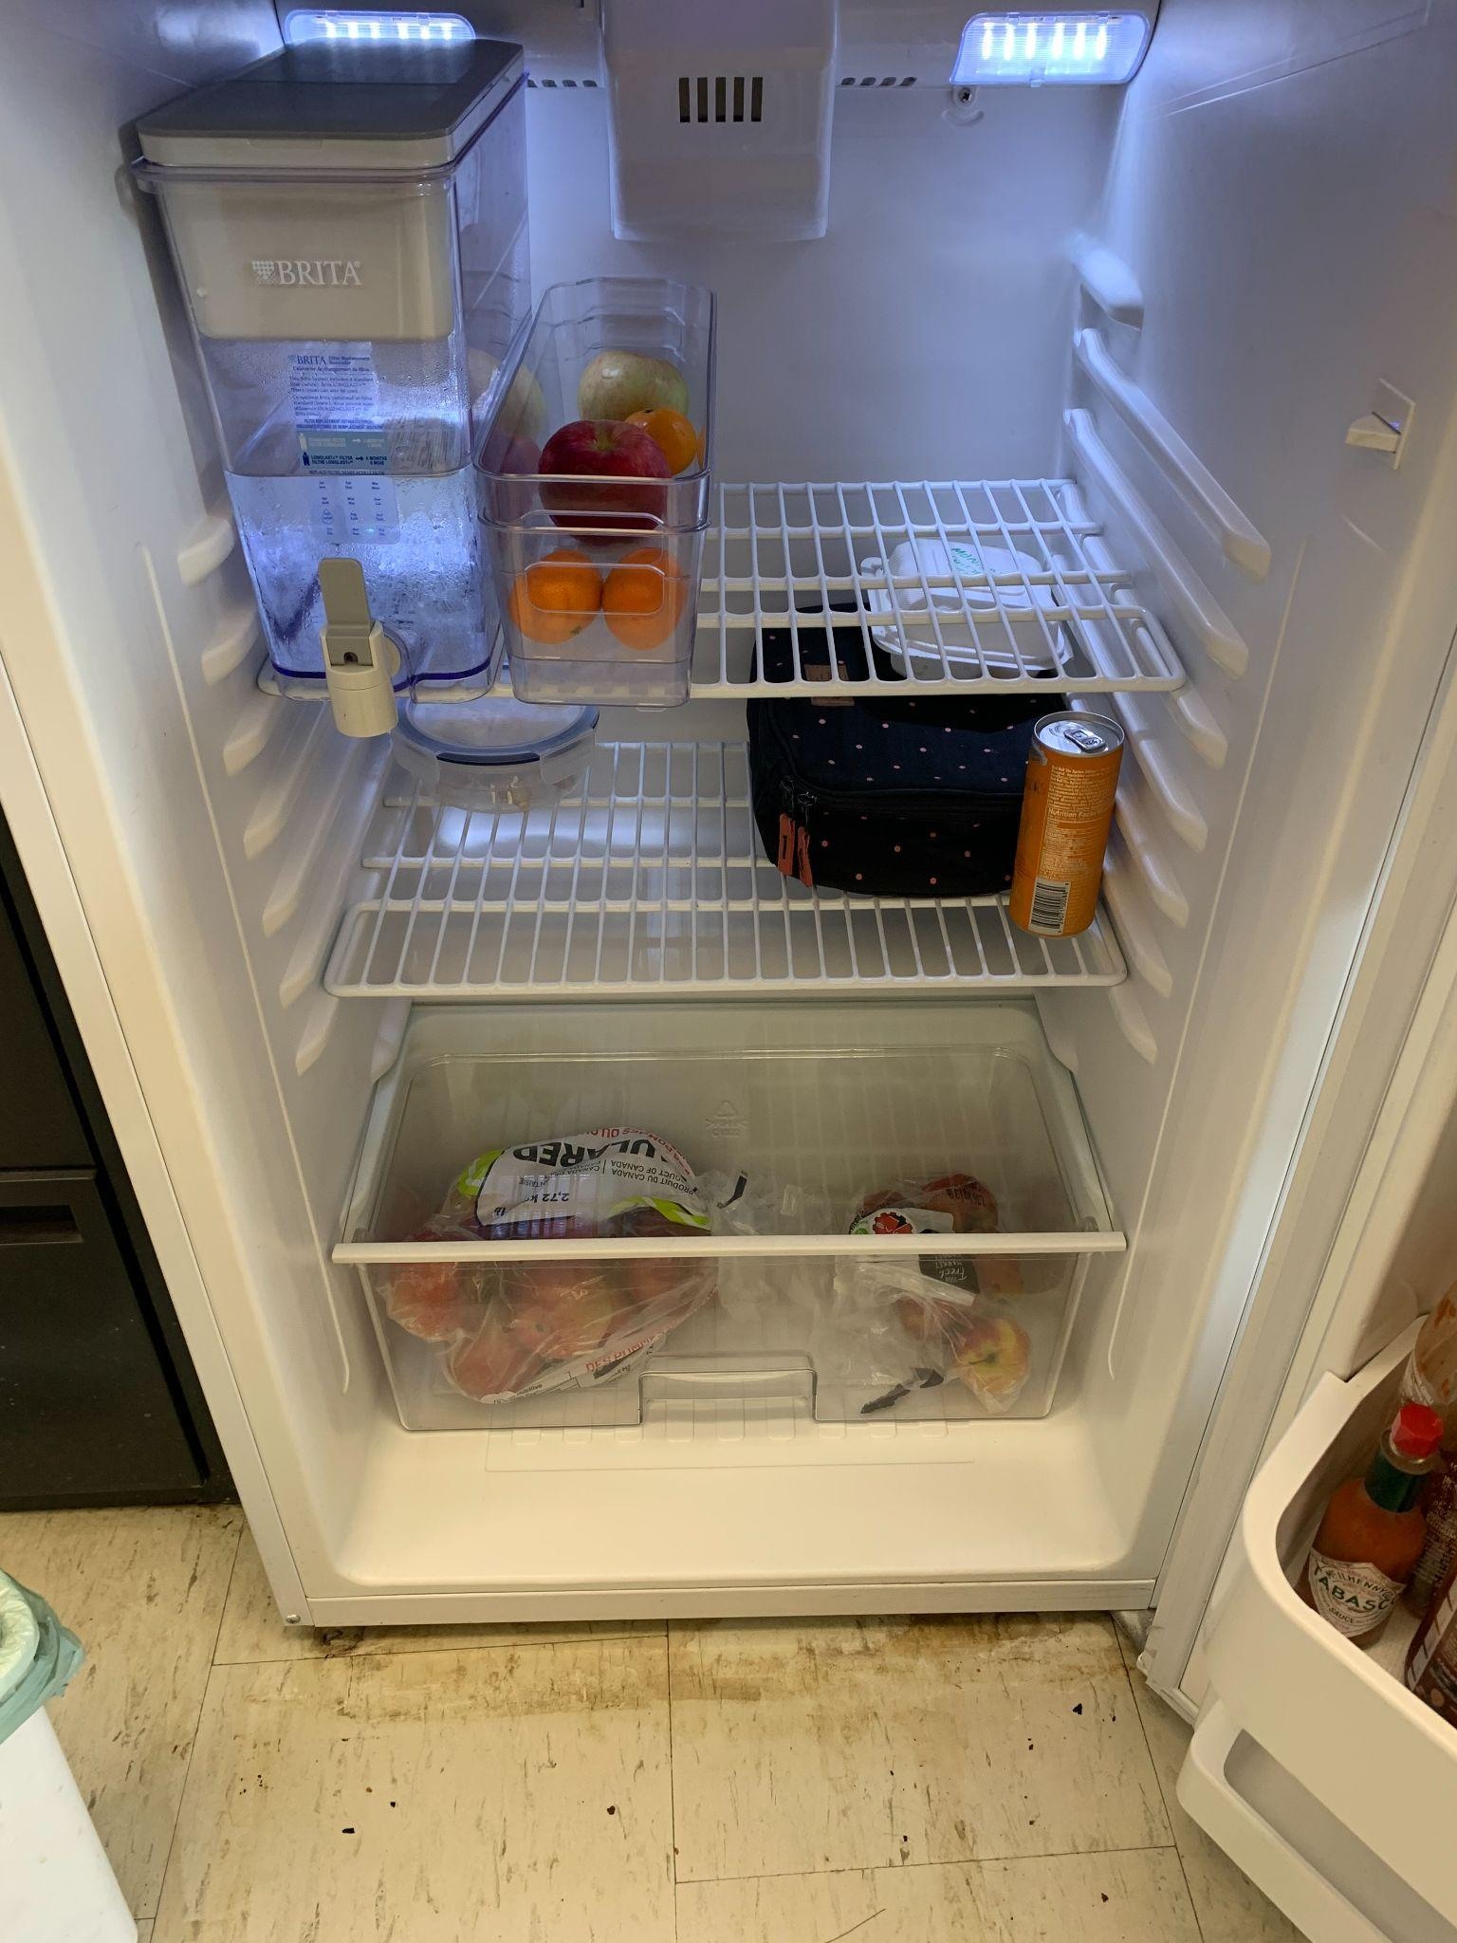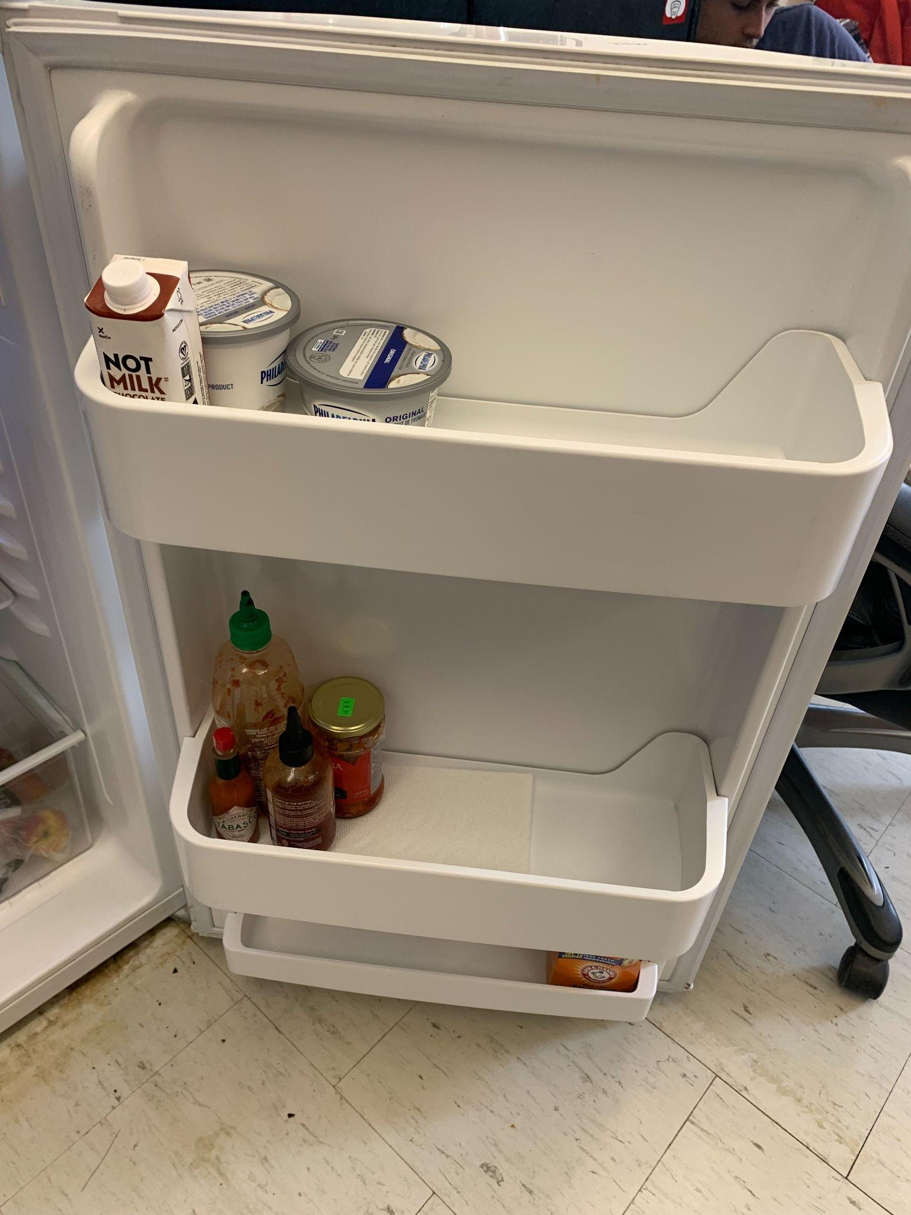  - Respect  - Keep office nice-ish (that means execs too!!!!!!!!!!!!!!!)  - EngFrosh Stuff……  - Mugs  - Office Hours  - Very tentative office hours have been posted  - When we hire first years I will redo the office hours and add in the quiet hours  - Small windows painting???  - Furniture for office?  - Shelf  - Table + thingy….. | -Mug drop competition
Publications Director | 2 minutes
- First year rep post posted fr  - Making da posters frfr  - Working on updated price list  - How many moneys is a sweatpant  - Plz stop giving me merch stuff lolz that’s not my job (i will talk abt this more in pubs meeting) | - Folksy 1 post pwetty please  - NOT POSTER ily <3  - Member 30  - Non member 35
Technical Director | 5ish minutes
- Fixed the website and learned how to fix the website whenever it doesn’t wanna SSL, which was fun  - Apparently toner for our printer is super duper rare and has never been sold ever(this is an exaggeration, but no local options really) The options are the following:  - https://www.printersplus.net/Xerox-C230-C235-Black-Toner-Cartridge-1-500pgs $100 black, $110 colour  - https://www.123ink.ca/p-396427-xerox-006r04383-bk-oem-xerox-006r04383-original-black-toner-cartridge $105 black, $120 colour (they also have “high yield cartridges” which are double the pages printed and $150)  - I gotta figure out 3d print queue. And post printing rules along with it. And we need to tell people yeah we have free 3d printing but you can’t print infinite bricks of filament forever for free.  - Do we actually want our landline up and running? I wont do it unless it’s important | <3
4th Year Representative | x minutes
- Can’t attend meetings as I am in class from 6-9pm  - Met with Grace for fourth year event  - Inquiring with other fourth years to gauge interest in a pub night | Slay ty -G
3rd Year Representative | 2 minutes
- Have not done much because engfrosh busy 🙁
- Dr. John Hayes is the MAE Department’s EDI and student wellness chair. Possible good connection to have…
- I’m going to start pushing the 3rd year feedback form again because things are starting to get settled again.
- Once we have some more responses, I’d like to approach a department rep like Karen Taylor or Ed Cyr.
- Need to start researching event ideas and their feasibility and then I’ll report back to Events.
2nd Year Representative | x minutes
1st Year Representative | x minutes

Discussion Items

Team Successes
** Did someone have a success this week? Did someone really help you out? Something notable happened? Write it here! **
- Survived engfrosh (&the office wasn’t in complete shambles!!)

